**Kashish Mamania**

**B1-16010122104**

**Tutorial 1**

Q1:



**Code:**

x=c(23, 27, 28, 29, 30, 31, 33, 35, 36, 39)

y=c(18, 22, 23, 24, 25, 26, 28, 29, 30, 32)

r = cor(x,y)

plot(x,y,main="scatter diagram",xlab="soil temp", ylab="germination")

cat("coefficient of correlation is", r)

paste("name & roll no", "Kashish.M 16010122104")

OUTPUT:

**coefficient of correlation is 0.9955072**

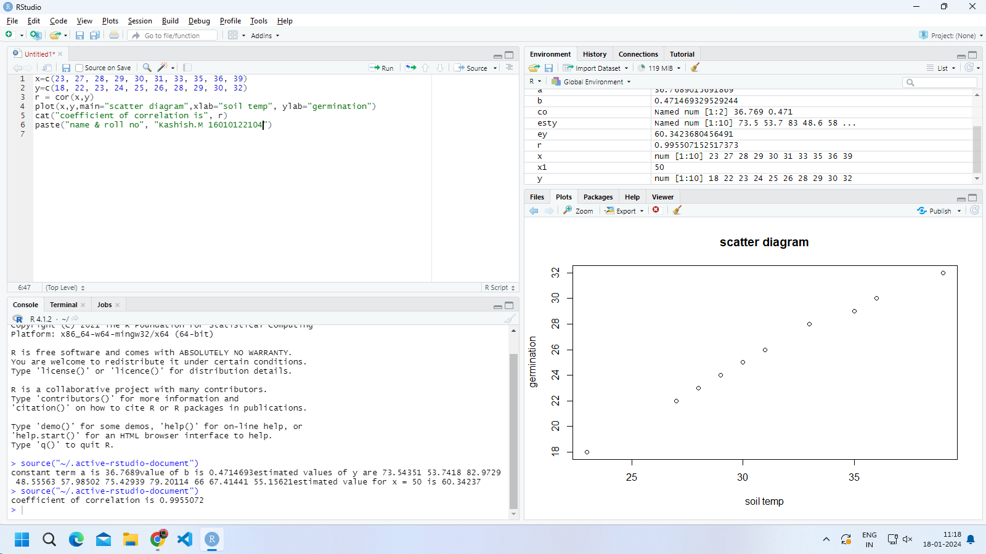

Q2:

Find the equations regression line for the following data

X : 78, 36, 98, 25, 45, 82, 90, 62, 65, 39.

Y : 84, 51, 91, 60, 68, 62, 86, 58, 53, 47.

Estimate the value of Y when X is 50

**Code:**

x=c(78, 36, 98, 25, 45, 82, 90, 62, 65, 39)

y=c(84, 51, 91, 60, 68, 62, 86, 58, 53, 47)

r1=lm(y~x)

co=coef(r1)

mco=matrix(co)

a=mco[1,1]

cat ("constant term a is",a)

b=mco[2,1]

cat ("value of b is",b)

esty=fitted(r1)

cat ("estimated values of y are", esty)

x1=50

ey=a+b*x1

cat ("estimated value for x = 50 is",ey)

plot (x,y,pch="+")

points(x,esty,pch="*")

lines(x,y , col="green")

lines(x,esty , col="red")

paste("name & roll no", "Kashish.M 16010122104")

OUTPUT:

**estimated value for x = 50 is 60.34237**

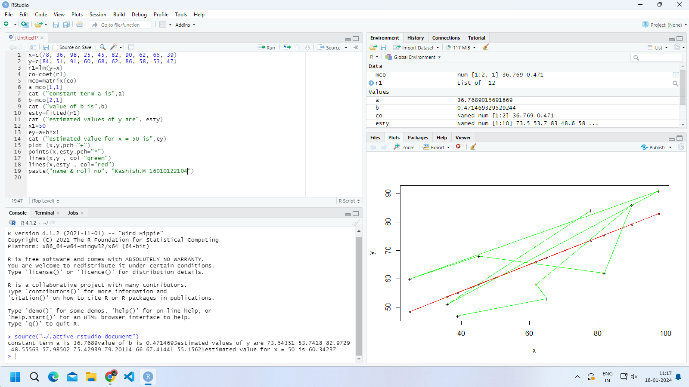

Q3:

Find the equations regression line for the following data

X : 78, 36, 98, 25, 45, 82, 90, 62, 65, 39.

Y : 84, 51, 91, 60, 68, 62, 86, 58, 53, 47.

and value of X when Y is 90.

CODE:

x=c(78, 36, 98, 25, 45, 82, 90, 62, 65, 39)

y=c(84, 51, 91, 60, 68, 62, 86, 58, 53, 47)

r1=lm(x~y)

co=coef(r1)

mco=matrix(co)

a=mco[1,1]

cat ("constant term a is",a)

b=mco[2,1]

cat ("value of b is",b)

estx=fitted(r1)

cat ("estimated values of x are", estx)

y1=90

ex=a+b*y1

cat ("estimated value of X is when y = 90",ex)

plot (x,y,pch="+")

points(estx,y,pch="*")

lines(x,y , col="green")

lines(estx,y , col="red")

paste("name & roll no", "Kashish.M 16010122104")

Output:  
**estimated value of X is when y = 90 is 90.53237**

